Lab Name

Lab overview
Start with the lab overview. This is the “section” of the lab. The numbering will be x.1 of whatever lab number you have for your workshop. If this is lab 01, then the section will be 1.1.

Persona represented in this lab
If your lab is persona based, describe it here. Also notice the two colors you can use to highlight commands or special words you want to draw attention to.
Example:
The Data Engineer persona is the likely role to perform the various Collect tasks shown in this lab.
Persona (Role) | Capabilities
  Data Engineer | Data Engineers build and optimize the systems to allow data scientists and business analysts to perform their work. The Data Engineer ensures that any data is properly received, transformed, stored, and made accessible to other users.

Bullet examples
Prose here….
- Bullets like this
- Bullets like this

A modular subsection example
This is an example of a modular lab build sub-section.
This example shows how you can build your lab workbook so that each lab is stand alone. As such, you may have to tell the student how to do things in each lab, not assuming they did anything in an previous lab. Below is an example.
- If you are starting this lab stand-alone (without going through previous labs) do the following:
- Double-click the desktop icon: Cloud Pak for Data Web Client

- The CPD web client GUI displays as shown.
Use cpduser and cpdaccess for the Username and Password and click Sign In.
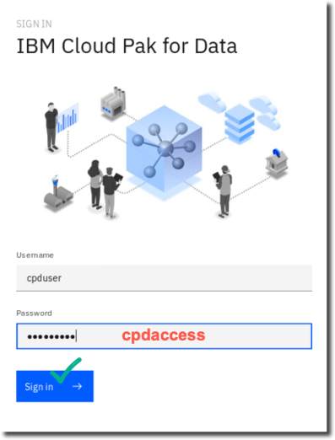
Above is an example of what you DON’T want to do. Don’t create your lab workbook with orphaned images. If you have prose that describes an image, make sure the prose and the image are always on the same page together.

For screen shots, get and use SnagIt: https://natecs.raleigh.ibm.com/software-toolkit/

“Chain” command example
Below is an example of how to “chain” commands together using an arrow image between them. There are actually five different clicks required to do this step, but they are described with one chained command and two screen shots.
Notice too the screen shots have a green arrow to indicate where on the screen to click.
- Click Collect My Data Databases Db2 Advanced Edition ellipsis Open
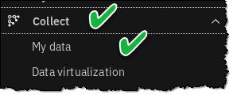
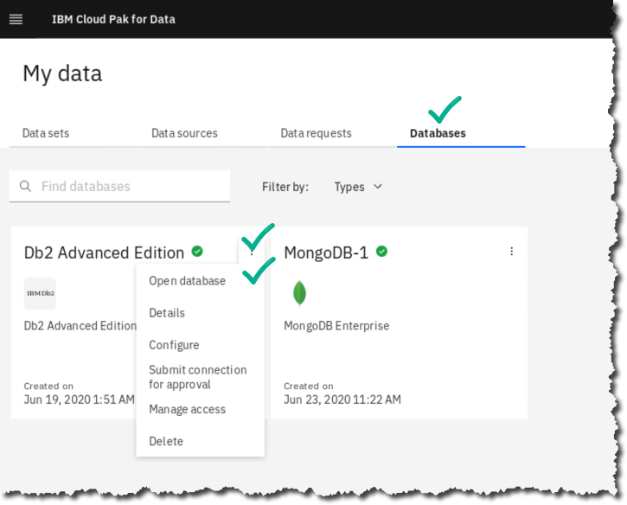

Tip example
Below is an example of how you can create a special comment, hint, or tip. These can be useful to guide your student in places where you know the lab may fail for some reason. It can help them get through it. Also note it is the lab persona who is giving the tip. If you don’t have a lab persona, use an icon you think will catch the students attention to indicate a tip, hint, etc.
This boxed comment can also be something you want to especially highlight in the lab for some reason.

  Data Engineer | Note: if you do NOT have a successful connection test as shown above, you should fix this by launching another CPD web client from the desktop and use the second web client to return to the Details screen of the Db2 Advanced Edition. Use both screens to make sure all the credentials match between the Details screen and the Connection screen, especially Username/Password.

Lab conclusion
Have a lab conclusion of some sort to highlight the main points of the lab as a review.

** End of Lab 0x – Lab Name
Lab by IBMer(s) who created the lab

Lab workbook design tips

Make a consistent story.
- Make sure your lab or labs flow from beginning to end. Start with a purpose and end with a purpose. It should not look hastily written with little thought put into the flow.
- Condense wording at the beginning of your lab and give the lab an overview
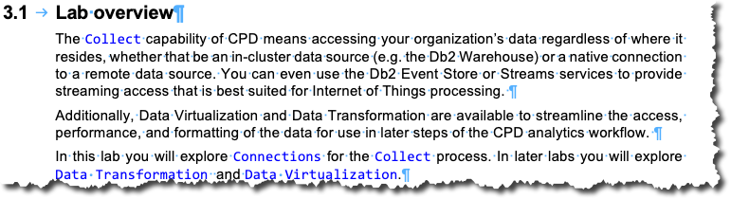
- Finish off your document with a Lab conclusion. This should be a brief summary of what the user should have taken away from the lab.
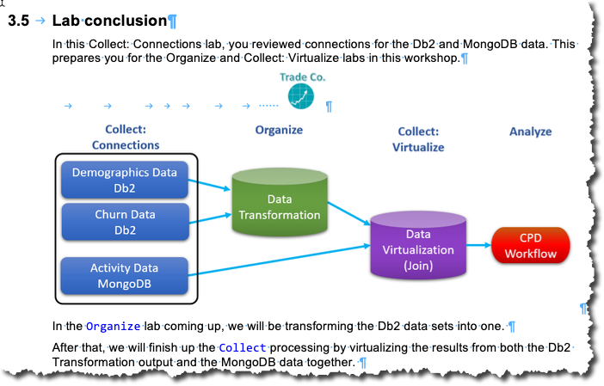

Make sure your formatting is clean.
- Start with a clear labeled title.

- Make sub-titles (subsections) for Heading 2 and Heading 3. These can be starting points for any lab exercise that needs to be repeated (or looped through) and they provide nice navigation points when using the Navigation Pane.
- Make sure these sections and subsections are based on when a new thought presented.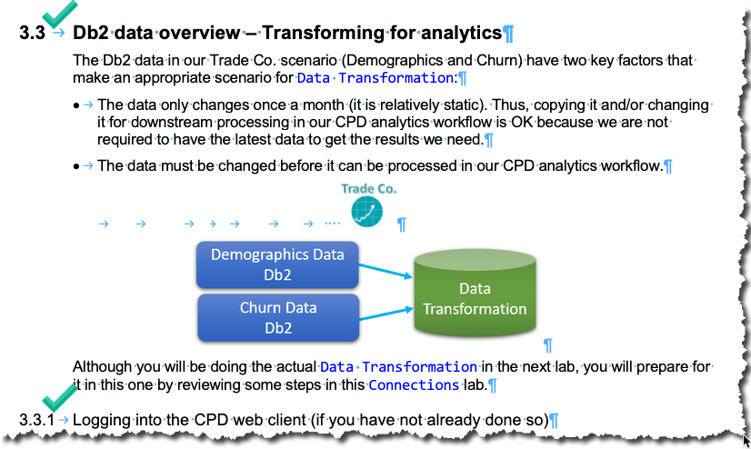
- Less words the better. Use descriptive pictures like arrows (or sometimes numbers)
- Spacing is key. Utilize your space on a page to look nice overall. Use the line spacing shown in this template: don’t OVER space between each step. This just wastes space.

- Line up your document. Notice that when you zoom out it should all look aligned.
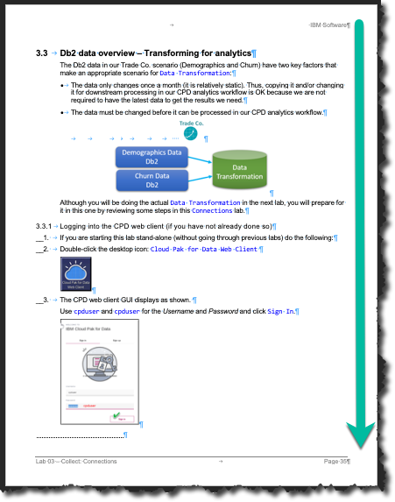
- All new sections (not necessarily subsections) should start with a new page.

Make sure your instructions are clear and concise.
- When giving your instructions make sure to include screenshots as needed.
- Screenshots should be zoomed in as much as possible, but not too much where the user can’t understand where to go on the screen.
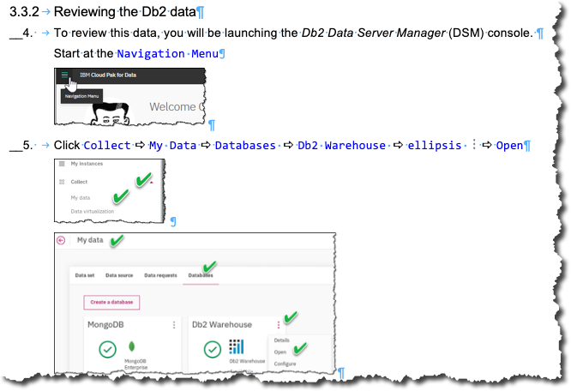

Review your document before publishing.
- Have the paragraph markers turned on to better see the final formatting.
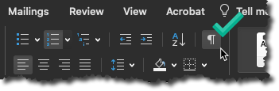
- Next ensure your header/footer has the correct page numbers
  - If you have multiple documents you are going to combine make sure all align together.
- View your document page by page to look for any floating screenshots.
  - Screenshots should always go with the text they are assigned to; they should NOT float to the next page as an orphaned illustration.
- Save your document with the appropriate title.
- Publish your document.

Documented are best practices tip by Burt Vialpando to John Lucas.
Questions regarding these best practices can be directed to John Lucas (Email: john.lucas@ibm.com or Slack: john.lucas)

Documented by John Lucas on 05/04/2020

A word about Markdown (.md) files (Burt Vialpando)

History of Markdown (.md) files
John Gruber, the creator of Markdown, outlines the main purposes of why he created Markdown here: https://fileinfo.com/extension/md
Markdown has two main purposes 1) simplified conversion of plain text to HTML, and 2) source code version control for web writers.

Why I do not use Markdown files for this workshop.
While Markdown has its benefits in the web writer world, in my opinion (and others) it has been overused and overhyped to force it to be everything to everyone.
See: What’s wrong with Markdown https://www.adamhyde.net/whats-wrong-with-markdown/
That said, I have key reasons that I do not employ Markdown for creating our workshop workbooks:
- Source control / open sourcing is not desired.
We are not creating the lab workbooks to be updated by just anyone, with forking, open sourcing, etc. being used. We want to control exactly what the final product will be for the consumers of these labs are just as any author of a novel or a song would want their final product to look like. This is not a “build by committee” situation where crowd sourcing rules; our labs have a purpose, personality, scope, etc. which does not lend to the purpose of .md files.
Nor is the workbook a set of “code” the requires source control. Only the authors of the workbook exercises will be updating the labs. Our process does not have to be controlled by Github, which again is an environment for coders and developers, NOT a publishing environment.
- Final workbooks are created in PDF for consumption
The workbooks will be created as PDFs and then consumed either digitally (with a PDF reader) or physically, with a printed copy of the workbook. The final product is not a set of HTML pages as Markdown lends to.
- No easy navigation or extensible formatting
Markdown was not created to be navigated and extensively formatted as ANY word processing software (like Word) that has a Navigation pane and extensive color, font, table of contents and other formatting features readily built in. As a result, various Markdown plug-ins are required to augment this. Why jump through these hoops to make Markdown be what it is not good for when we can just use Word to create the document and PDF Maker to build the PDFs that will have all these things naturally?
Final word of thought comes from this author on Why you should and should not use Markdown:
“There is no way to manage longer documents in Markdown... You can’t easily incorporate pieces together, reuse content, or even create a table of contents. Once you are managing something larger than a single page of formatted text, Markdown kind of throws up its hands.”
https://medium.com/@stymied/why-you-should-and-should-not-use-markdown-1b9d70987792

